### Project Name: ***Fast Tops***

### Team Members

Ryan Rhodes (rbr673)

Dahlia Lopez (dtl583)

Christopher Yoon

Erick Jones (ecj333)

### Problem Statement

Tops are one of the oldest archaeological identified toys and have been used as toys, for gambling, and even to tell prophecy. Newer top designs include beyblades, 3D-printed designs, and air-powered tops. While the concept behind tops is simple, twist and spin, the idea continues to live on. Perhaps ForeverSpin says it best:

*“WHY A SPINNING TOP? THERE WILL BE SOMETHING IN IT FOR YOU FOREVER.*

*Perhaps you need a little boost in creativity or focus, or you need to de-stress a bit. Maybe you're in search of a gift that lasts forever or want to compare weight and touch different metals. Or you just like a bit of competition or you love minimalistic art. Engineers, kids, designers, collectors... No matter how old, how wise and how smart you become there will be something in it for you Forever.”*

Our objective is to design a high quality collectible spinning top that shows off the capabilities of SLS additive manufacturing. Our top should be novel, spin well, and durable. We plan to focus on the novelty of the top because we can make intricate and complicated designs with SLS that have never been seen before. We believe with these tools we can create a custom high quality top that is visually stunning, has a unique character, and of course spins well.

### Customer Needs

Our team decided to aim our product towards collectors. Our ideal customer is an avid collector of spinning tops or someone who appreciates a high quality desk toy. With the fidget spinner craze that hit the markets a few years ago, the market for high quality spinning tops also began to grow. We are basing our customer needs off those of someone who may be looking to purchase a high quality, novel top.

Our first focus of customer needs is the appeal of the product. We will design a spinning top that is attractive to the customer and something that people will be proud to show off. It will have an aesthetically pleasing design that will grab anyone’s interest. It will also show off the capabilities of additive manufacturing, and more specifically SLS, and be a spinning top that is truly unique.

The next main category of customer needs is performance. Our top must be able to perform well, otherwise the appeal of the top will go down. Spin time is one of the most important performance metrics. The top must be able to spin for a considerable length of time without falling over. The top must also be able to spin at high enough rotational velocity to achieve this considerable spin time. The top must be durable so as to not break if it were to collide with another surface while spinning or if it were to fall from a height of a desk or a table.

The last category of customer needs is the cost of the top. Current high quality spinning tops on the market currently range from $20 to over $200. We aim to have the cost of our somewhere between that. We aim to have our cost be affordable for the customer based on the detail and size of the spinning top. Below is a table of our customer needs, with each need given a weight of importance with 5 being most important and 1 being least important.

|  |  |  |  |
| --- | --- | --- | --- |
| **Customer Needs** | | | |
| **Appeal** | | | **WT** |
| Aesthetically Pleasing | | | 5 |
| Novel/Unique design | | | 4 |
| AM exclusive construction | | | 4 |
| **Performance** | | |  |
| Long Spin Time | | | 3 |
| High Spin Speed | | | 4 |
| High Durability | | | 5 |
| **Cost** | | |  |
| Affordable cost compared to similar high-end tops | | | 4 |

### Spec Sheet

Based on the customer needs analysis, our team generated a requirements list for our potential product.

|  |  |  |  |
| --- | --- | --- | --- |
| **Requirements List** | | | |
| **Requirements** | | | **Specifics (Demand/Wish)** |
| Aesthetic Appeal and Customization | | | N/A (D) |
| Long Spin Time | | | > 30s (W), >10s (D) |
| High Spin Speed | | | > 5000 rpm (W), >3600 rpm (D) |
| High Durability | | | > 2000 launches (W), >500 (D) |
| Low Cost (compared to high-end spinning tops) | | | < $300 (D), <$100 (W) |
| Portable Size | | | < 3”x3”x5” (D), 3”x3”x3” (W) |
| Portable Weight | | | < 6 oz (D), < 3oz (W) |
| Low Number of Parts (Ease of Assembly) | | | < 3 parts (W) |

As mentioned in the customer needs analysis, aesthetic appeal is an important factor to consider in the product design phase. The geometry of the top should also take advantage of the unique capabilities offered by AM. Quantifying attractiveness in numbers is difficult, since it is inherently subjective. One idea would be simply surveying potential customers. For example, our team can ask a group of people to give 0 to 5 points based on aesthetic appeal. Our goal could be to have an average of more than 3.5 out of 5.

Long spin time, high spin speed, and high durability is important. We would want the top to spin for at least 10 seconds, ideally over 30 seconds like we expect from regular tops. AFor spin speed, a typical rpm for plastic Beyblades launched with a launcher is around 5000 RPM. Our goal is to reach this baseline, but for hand-spun tops we could lower the expectation. The minimum spin speed (in revs per second) for a typical top to be stable is roughly equal to √g/a where g=9.81m/s2 and a is the radius of the top. (<http://www2.eng.cam.ac.uk/~hemh1/gyroscopes/spinningtop.htm>) For our top with expected radius of 4-5cm, the minimum spin speed is around 62-78 rev/s, or 3600-4800 RPM. Therefore, we put 3600 rpm as the minimum requirement for spin speed. High durability is also important. The top’s important features should be placed at locations that don’t come into physical contact with the environment. The product should last more than 500 typical launch cycles at minimum, considering that Nylon isn’t best at handling high stresses.

Low cost [ economic justification part talks about the price. I think we should integrate two parts together, or move that information to here]

Portable size and weight is also important. Ideally it would fit inside a pocket (3”x3”x3”), but for special tops that shows off intricate geometry, we gave a more generous set of dimensions. For weight, a Beyblade with a launcher weighs around 2-3oz, so we expect to be around that range.

Benefit of AM is that we can consolidate parts that would otherwise need to be assembled in traditional manufacturing. We would like the total number of parts to be below 3.

### Economic Justification for SLS

Intricately designed spinning tops cost around $20 retail. They are generally small (can fit in the palm of your hand) and as a result use very little material. Precision machined metal tops like those made by ForeverSpin are between $35 and $100. More intricate and unique metal tops like those made by Billet Spin can retail as high as $345. They are also small but are made of metal which is more expensive. Air powered tops like the Zephr retail at around $100. They are much bigger than the intricate tops but still relatively small overall and use just a little material.

To be economically competitive we must be able to print multiple designs at an average cost somewhere between $20 - $350. Obviously this will be dependent on the material and type of top but these are the ranges. The build envelope for the SLS machine that we will be using is around 37x32x45cm (53,280cm^3), and the buildable volume is 32x27x40cm (34,560cm^3). Each team will aim for less than third of that volume. Nylon-12 powder is around $45/kg from 3rd party sellers, with powder density around 0.5 g/cm^3. At $45/kg, the cost to fill the chamber is around $1600 if using 100% virgin powder, including ⅓ extra for overflow. If only half of the powder is virgin powder, the price is around $800 to fill the entire chamber. So the material cost for ⅓ of the build envelope is at most around $540. If we set our build volume as 6”x6”x16” (15 x 15 x 40cm), and the top occupies around 3” x 3” x 3” in volume, we can produce 20 tops (4 tops per layer, 5 layers). This will give us the material cost of $27 per top as maximum. Variables such as the size of the top (it may be larger or smaller than given volume), labor cost, and machine operating cost may change the actual cost, but targeting under the $100 line certainly seems feasible.

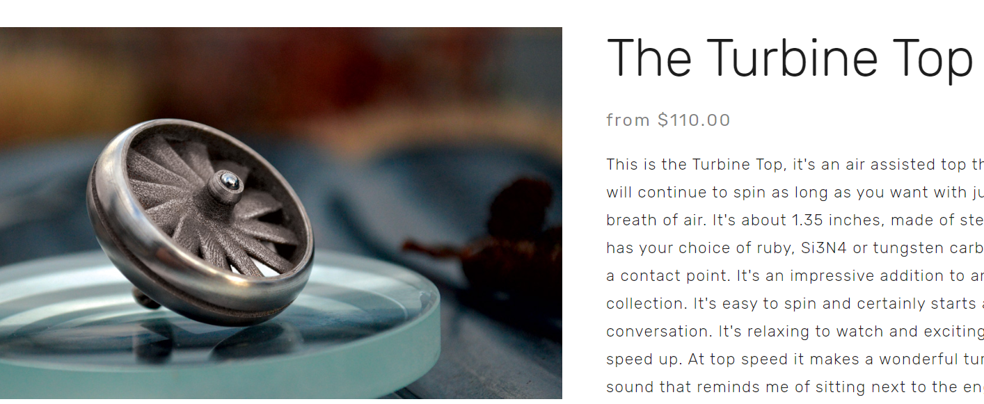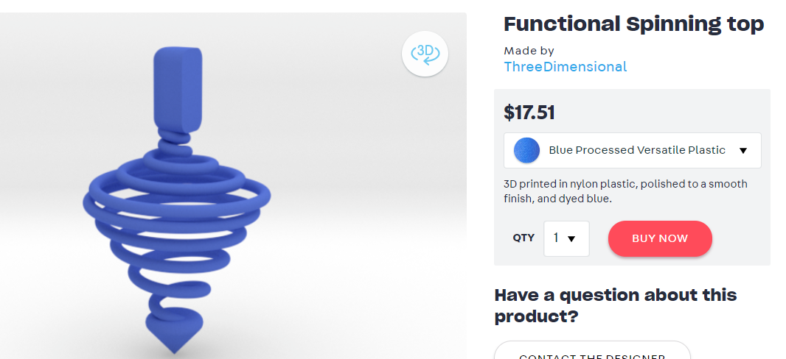

### 

<https://www.billetspin.com/maelstrom>

[**https://www.shapeways.com/forum/t/tornado-spinning-top.29528/**](https://www.shapeways.com/forum/t/tornado-spinning-top.29528/)

[**https://www.shapeways.com/product/NJ4TFJV6W/functional-spinning-top?li=shareProduct**](https://www.shapeways.com/product/NJ4TFJV6W/functional-spinning-top?li=shareProduct)

<https://foreverspin.com/>

<https://db-tops.com/shop/the-turbine-top>

### Concepts

Following the creation of our problem statement, we took the first steps towards deciding on our design by having each member of the team draft up various conceptual designs individually and then come together to share them as a group. Each member of the team utilized a classic brainstorm method by jotting down and sketching various design ideas, with each concept seeking to take advantage of the benefits of SLS printing, including complex geometries, feature resolution, and strength of the part. Once everyone had each prepared a few concept ideas, we met as a group through Zoom and presented each idea, explaining the features and functions of each design. We then discussed the concepts together, and voted as a group for our top five design choices. These top five choices narrowed down our options to set us working towards a leading concept and possibly utilizing our favorite features within the top five choices into our final design. The five leading concept sketches are as shown below:

Choice 1: UT Tower

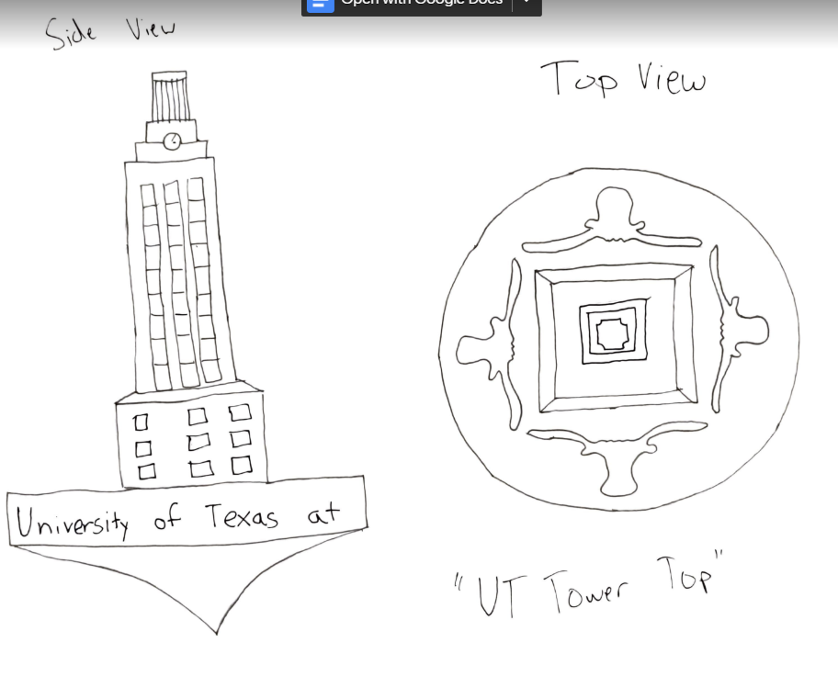

This design includes a small detailed model of the UT Tower as the handle of the top. The flared circular base has four longhorns at each base of the tower. These are seen from the top view of the top, and can be made to either cut into the base or extrude out of it.

Choice 2: Air-Powered

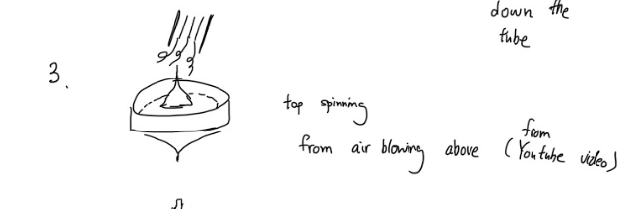

This top design is unique because it is powered by air blown directly above the fan. This idea was inspired from a Youtube video (<https://youtu.be/D8nSKMdYse8>). The top of the fan is made up of turbine blades that cause the body to spin when air flows through. The top would be powered by air blown through the blades from down a tube or straw.

Choice 3: Spinning Airplane

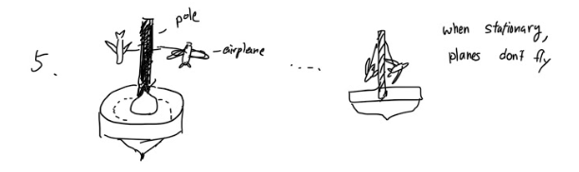

This top design is a modified version of the air-powered top. The base is spun by blowing air on it. The top part contains two small airplanes hanging from a tall handle. The airplanes as well as attachment to the handle would be printed in one whole piece. When the top is spun, the planes will pull apart and fly as the body spins - much similar to the movement of a tether ball when struck. On a typical top, this design would be infeasible because the attachments would impact the stability of the top. But air-powered configuration can take advantage of constant air supply from blowing air, and would make this design possible.

Choice 4: Coronavirus

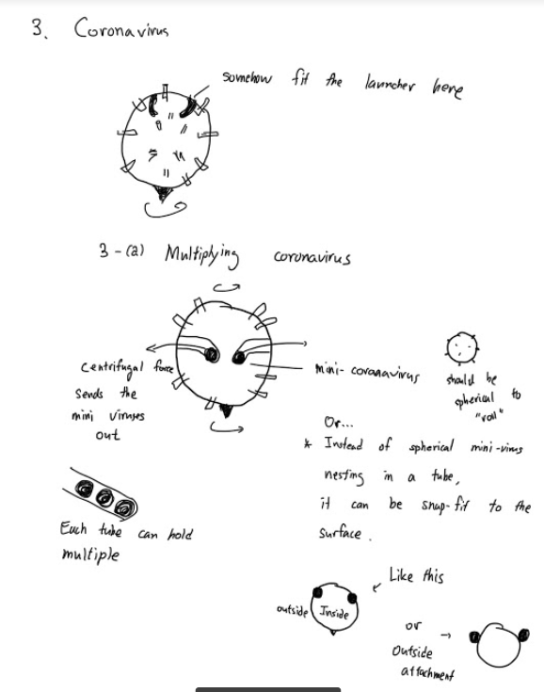

This top is designed to be launched into motion using a launching mechanism similar to that of the popular Beyblade tops sold by Hasbro. This top is meant to be shaped like a single SARS-CoV-2 virus protein, commonly known as COVID-19. This design would have small chambers inside that hold small, sphere-shaped bearings, which would fly out of the top when spun, mimicking the “spread” of the virus.

Choice 5: Weighted Spiral

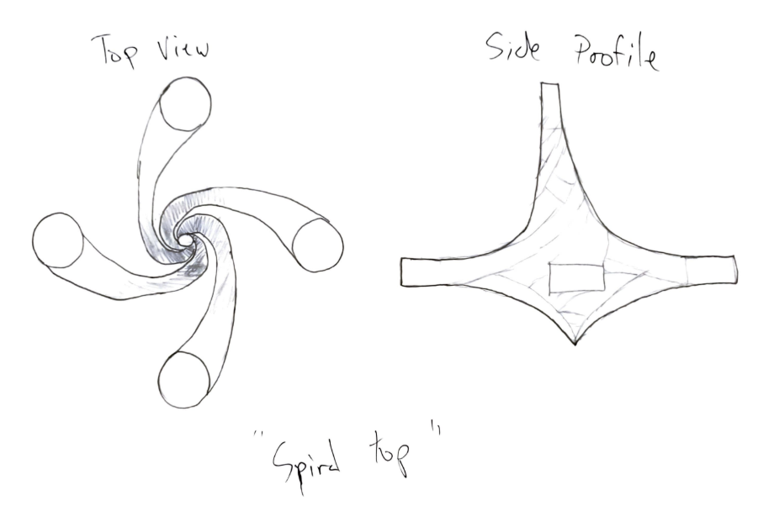

This final design has a unique geometry in which the body is made up of four rigid spiraling bars. The bars twist together to create the shape of the top and meet at the tip where the top balances and spins on.

### 

### Updated Gantt Chart

